August
2018
Physics

Sunday | Monday | Tuesday | Wednesday | Thursday | Friday | Saturday
 |  |  | 1 | 2 | 3 | 4
5 | 6 | 7 | 8 | 9 | 10 | 11
12 | 13 | 14 | 15 | 16 | 17 | 18
 |  |  | Teacher Inservice | Teacher Inservice | Teacher Inservice
19 | 20 | 21 | 22 | 23 | 24 | 25
 | First Day of Classes:  -Course Intro. | -Course Syllabus  -Notecard STEM activity | -Lab Safety overview  -Scientific Method in Physics  -Spaghetti Lab | -Spaghetti lab continued:  Continue measurements | -Finish Spaghetti Lab questions  -Calculating for larger objects using data
26 | 27 | 28 | 29 | 30 | 31
 | -Supporting a student with Spaghetti  -Begin Units & Metrics | -Metric & other unit conversions  -Sig figures  -Applying dim. analysis | Begin Measurement Lab:  -Applying metrics & sig figs |  | Measurement Lab:  -Collect Data

September
2018  Physics | 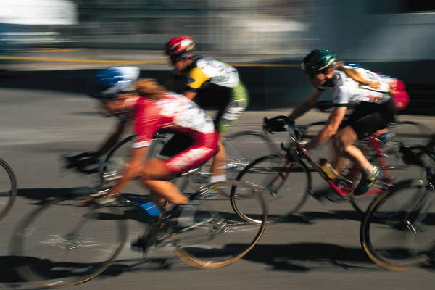

Sunday | Monday | Tuesday | Wednesday | Thursday | Friday | Saturday
 |  |  |  |  |  | 1
2 | 3 | 4 | 5 | 6 | 7 | 8
 | Labor Day Holiday | -Finish Measurement Lab  -Metric & Units Practice Problems | -Metrics & Units Review  Units Quiz  -Begin Motion  Simple linear  -Lab Report Guidelines |  | -Using Probewear to collect data  -Velocity & Acceleration Lab Design
9 | 10 | 11 | 12 | 13 | 14 | 15
 | -Velocity & Acc. Lab:  Collect Data  Analyze Data | -Finish Vel. & Acc. Lab  -Lab Report | -Applying Kinematic Equations  -Freely Falling Objects |  | -Applying Kinematics Equations:  Chapter 2 Problems
16 | 17 | 18 | 19 | 20 | 21 | 22
 | -Reflex Lab:  Using “g” to calculate reaction time | -Finish Reflex lab  -Work on chapter 2 problems | -Kinematics Review Day:  Whiteboard sharing activity |  | Chapter 2 Test:  Linear motion (1D Kinematics)
23 | 24 | 25 | 26 | 27 | 28 | 29
 | -Finish Ch 2 Test (if needed)  -Begin Vectors  Compass directions & angles | -Vector Addition  - Begin Vector Treasure Hunt:  (Vector Cards) | -Vector Treasure Hunt:  Finish Cards  Map |  | -Finish Vector Treasure Hunt:  Finding the treasure
30

October
2018
Physics

Sunday | Monday | Tuesday | Wednesday | Thursday | Friday | Saturday
 | 1 | 2 | 3 | 4 | 5 | 6
 | Begin 2D motion:  -Horizontal projectiles  -Ch. 3 problems | -Horizontal Projectile Lab:  *Making a  Basket | -Finish horizontal projectile lab  -Work on Ch 3 problems |  | Angled projectiles:  -Predicting range  -Deriving the big equation
7 | 8 | 9 | 10 | 11 | 12 | 13
 | Problem-solving with angled projectiles | -Angles Projectile Mini-Lab  -Ch. 3 Problems | Angled projectile mini lab:  -Test calcs |  | -Relative Motion  -Review 2D motion
14 | 15 | 16 | 17 | 18 | 19 | 20
 | -Angled Projectile motion  -Problem solving practice | -Review Vectors & 2D motion  -Angled projectile demo | Quiz:  -Vectors & 2D motion  Newton’s Laws:  -Drawing free body diagrams |  | Teacher Inservice
21 | 22 | 23 | 24 | 25 | 26 | 27
 | Forces & Newton’s Laws:  -Theory and practice  -Newton’s Laws examples | Tricks with Newton’s Laws mini lab:  -Applying the magic | -Using FBD’s with Newton’s 2nd Law  -Begin Young Frankenstein & Forces |  | Teacher Inservice
28 | 29 | 30 | 31
 | -Using FBD’s with Newton’s 2nd Law  -Finish Young Frankenstein & Forces | Applying Newton’s laws:  -Balanced & unbalanced forces | -Force Types Lab:  *Analyzing different types of forces

November
2018
Physics

Sunday | Monday | Tuesday | Wednesday | Thursday | Friday | Saturday
 |  |  |  | 1 | 2 | 3
-Finish Force Types Lab
-Newton’s laws problems
4 | 5 | 6 | 7 | 8 | 9 | 10
 | -Friction Forces  *What is μ?  -Writing Newton’s 2nd Law equations | Darwin Award physics:  -Analyzing events with FBD’s | Physics Practice problems:  -Applying Newton’s 2nd law |  | Complex FBD’s:  -Inclines  -Tension at angles
11 | 12 | 13 | 14 | 15 | 16 | 17
 | Professional Development | Friction Lab:  -Collecting data  -Begin Data analysis | Friction lab:  -Finish Data analysis  -Complete lab reports |  | Boat project design lab:  -Cardboard boat challenge
18 | 19 | 20 | 21 | 22 | 23 | 24
 | -Finish boat blueprints  -Begin boat construction | Boat construction | Begin Boat testing | Thanksgiving Holiday | Thanksgiving Holiday
25 | 26 | 27 | 28 | 29 | 30
 | -Finish Boat Testing  -Newton’s laws review | -Finish Newton’s laws review  -Finish practice questions | -Newton’s laws Unit Exam  -Begin Work & Energy |  | Work & Energy:  -Energy types

December
2018
Physics

Sunday | Monday | Tuesday | Wednesday | Thursday | Friday | Saturday
 |  |  |  |  |  | 1
2 | 3 | 4 | 5 | 6 | 7 | 8
 | Applying energy concepts:  -Roller coaster design & calculations | Work & Energy theorem:  -Problem solving techniques  -Finish coasters | Intro to Simple Machines:  -Types  -Begin simple machines lab |  | -Finish Simple Machines Lab  -Work & Energy problems
9 | 10 | 11 | 12 | 13 | 14 | 15
 | -Finish Work & Energy problems  -Review for quiz | -Work & Energy Quiz  -Introduction to toy project  *toy selection | Toy Project:  -Engineering schematics  -Work on display |  | -Finish toy project  -Energy measurements
16 | 17 | 18 | 19 | 20 | 21 | 22
 | -Review for Semester Exam | -Review for Semester Exam | Semester Exams (1, 2, 3) | Semester Exams (4, 5, 6) | Teacher Work Day
23 | 24 | 25 | 26 | 27 | 28 | 30
 | WINTER BREAK | WINTER BREAK | WINTER BREAK | WINTER BREAK | WINTER BREAK

