January
2020 AP Physics 1 | 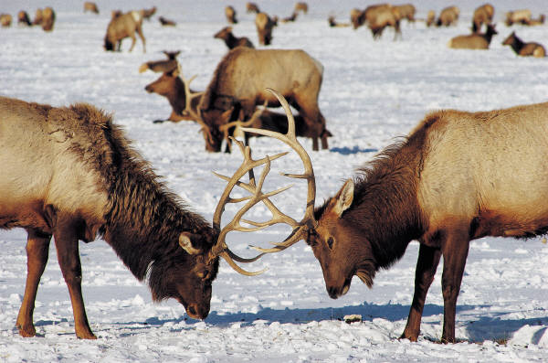

Sunday | Monday | Tuesday | Wednesday | Thursday | Friday | Saturday
 |  |  | 1 | 2 | 3 | 4
5 | 6 | 7 | 8 | 9 | 10 | 11
 | Review of Semester Exam  - Conservation of Energy | Rotational Kinematics:  -Using Rads  -Intro. to  Torque | Torque & Rotational Equilibrium  -Torque Lab | -Finish Torque Lab  -Torque practice questions | -Torque FR questions  -Rotation problem solving
12 | 13 | 14 | 15 | 16 | 17 | 18
 | Moment of Inertia:  -Applications  - Rotational KE  -Practice ?s | *Moment of Inertia lab:  -Rolling discs  *Finish practice  ?s | Moment of Inertia Lab:  -Setup  -Begin data  collection |  | Moment of Inertia Lab:  -Data collection  -Data analysis
19 | 20 | 21 | 22 | 23 | 24 | 25
 | MLK Holiday | Moment of Inertia Lab:  -Finish data  analysis | -Chapter 7.5 Conceptual Practice  -“I” Lab Report |  | Angular motion Free Response practice
26 | 27 | 28 | 29 | 30 | 31
 | Angular Momentum & Rotational KE  -Problem solving | -Practice Rotation Exam | Begin Rotational Dynamics Exam |  | Finish Rotational Dynamics Exam

February
2020 AP Physics 1 | 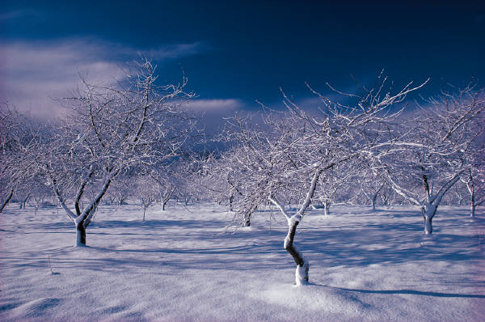

Sunday | Monday | Tuesday | Wednesday | Thursday | Friday | Saturday
 |  |  |  |  |  | 1
2 | 3 | 4 | 5 | 6 | 7 | 8
 | SHM:  Pendulum/Spring inquiry lab | SHM:  Pendulum/Spring inquiry lab | SHM:  Pendulum/Spring inquiry lab  -Finish data collection |  | Simple Harmonic Motion:  -Graphing & Applications  -Finish Lab report
9 | 10 | 11 | 12 | 13 | 14 | 15
 | SHM Practice Questions  -Harmonium | -Intro. to semester project  -Hooke’s Law Lab | -Finish Hooke’s Law Lab  -Work on SHM questions | ½ Day (4, 5, 6) | Inservice Day
16 | 17 | 18 | 19 | 20 | 21 | 22
 | President’s Day | SHM Free-Response practice questions | Review for SHM Test:  -Finish FR  -Gimkit |  | SHM Unit Exam  -Finish MC questions  -Begin FR
23 | 24 | 25 | 26 | 27 | 28 | 29
 | SHM Unit Exam  -Finish FR questions | *SHM Unit Exam  -Finish (if needed)  *Intro. to wave properties  -Mechanical waves | Mechanical Waves Lab:  -Inquiry into factors affecting waves  -Wave problems |  | *Interference & standing waves:  -Superposition  -Harmonics  *Standing waves inquiry lab

March
2020 AP Physics 1 | 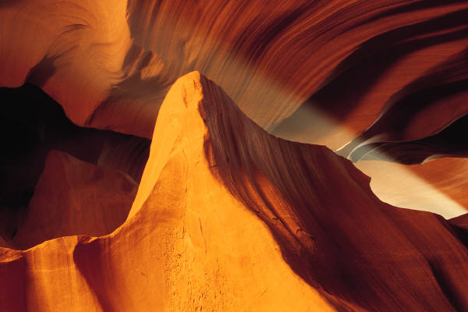

Sunday | Monday | Tuesday | Wednesday | Thursday | Friday | Saturday
1 | 2 | 3 | 4 | 5 | 6 | 7
 | -Finish standing waves inquiry lab  -Work on Wave Problems | -Speed of Sound Lab  -Standing Waves Problems | -Speed of Sound Lab  -Review Sound Waves  (MC Practice) |  | Inservice Day
8 | 9 | 10 | 11 | 12 | 13 | 14
 | Spring Break | Spring Break | Spring Break | Spring Break | Spring Break
15 | 16 | 17 | 18 | 19 | 20 | 21
 | -Standing Waves review  -Waves & Sound MC practice | -Sound waves FR practice  -Review for Unit Exam on Sound | Sound Wave test:  -MC Questions |  | Sound Waves Test:  -FR Questions
22 | 23 | 24 | 25 | 26 | 27 | 28
 | Intro to Electric Forces:  -Phet investigations | Begin Electric Forces:  -Coulomb’s Law  -Packing peanuts charge lab | *Finish peanut Charge lab  *Electric Force Problem-solving  -Applying Coulomb’s Law |  | Static Electricity review:  -Focus on Coulomb’s law  -FR practice
29 | 30  -Finish Coulomb’s law review | 31  Coulomb’s law quiz  -Applying Coulomb’s law

April
2020 AP Physics 1 | 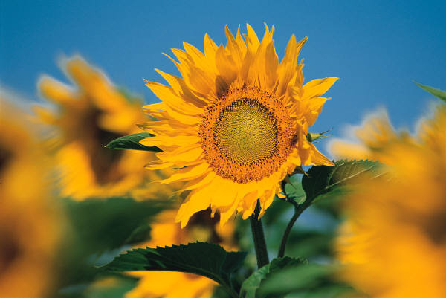

Sunday | Monday | Tuesday | Wednesday | Thursday | Friday | Saturday
 |  |  | 1 | 2 | 3 | 4
 |  |  | Intro to circuits:  -Ohm’s law  -Kirchoff’s loop & junction rules |  | Ohm’s law:  -Series & parallel circuits  -Complex circuits
5 | 6 | 7 | 8 | 9 | 10 | 11
 | Building Circuits Lab:  -Using a multimeter | Circuits Lab | Finish Circuits Lab |  | Ohm’s Law & Circuits Quiz
12 | 13 | 14 | 15 | 16 | 17 | 18
 | AP Exam Refresher:  -Prepping for Mock Exam | AP Physics 1 Mock Exam:  -MC | AP Physics 1 Mock Exam:  -FR |  | AP Exam Review
19 | 20 | 21 | 22 | 23 | 24 | 25
 | Finish DC Circuits | AP Exam Review:  -Kinematics  -Newton’s laws | AP Exam Review:  -Linear Momentum  -Work & Energy |  | AP Exam Review:  - Finish Work & Energy
26 | 27 | 28 | 29 | 30
 | AP Exam Review:  -Rotation & Gravity | AP Exam Review:  -Angular Motion | AP Exam Review:  -Simple Harmonic Motion  -Waves & Sound

May
2020 AP Physics 1 | 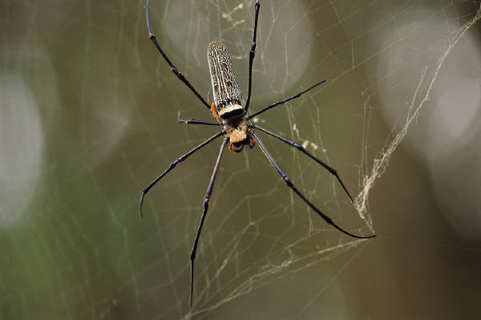

Sunday | Monday | Tuesday | Wednesday | Thursday | Friday | Saturday
 |  |  |  |  | 1 | 2
AP Exam Review:
-Electrostatics
-DC Circuits
3 | 4 | 5 | 6 | 7 | 8 | 9
 | AP Exam Review:  -Practice Blitz | AP Exam Review:  -Practice Blitz | IAP Exam Eve:  -Final Exam Tips  -Final Material Review | AP Physics 1 Exam Day (12;00 pm) | Senior Finals
10 | 11 | 12 | 13 | 14 | 15 | 16
 | Play-Doh Resistor Lab | Finish Play Doh Resistor Lab | Rube Goldberg Madness |  | Rube Goldberg Madness
17 | 18 | 19 | 20 | 21 | 22 | 23
 | Finish Rube Goldberg | Ig Nobel Project Due | Final Exams:  Periods 1, 2, 3 | Final Exams:  Periods 4, 5, 6 | Teacher Work Day
24/31 | 25 | 26 | 27 | 28 | 29 | 30

