January
2020 Physics | 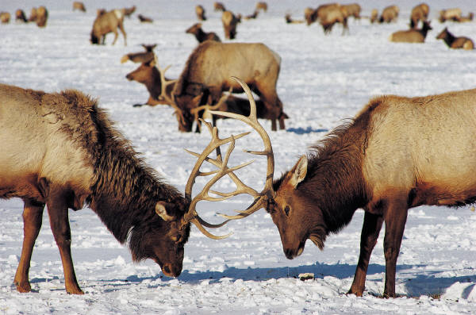

Sunday | Monday | Tuesday | Wednesday | Thursday | Friday | Saturday
 |  |  | 1 | 2 | 3 | 4
5 | 6 | 7 | 8 | 9 | 10 | 11
 | Boat project design lab:  -Archimedes principle  -Cardboard boat challenge | -Finish boat blueprints  -Begin boat construction |  | Boat construction | Begin Boat testing
12 | 13 | 14 | 15 | 16 | 17 | 18
 | *Finish Boat Testing  *Work & Energy:  -Energy types | Applying energy concepts:  -Roller coaster design & calculations |  | Work & Energy theorem:  -Problem solving techniques  -Finish coasters | Intro to Simple Machines:  -Types  -Begin simple machines lab
19 | 20 | 21 | 22 | 23 | 24 | 25
 | MLK Holiday | -Finish Simple Machines Lab  -Work & Energy problems |  | -Finish Work & Energy problems  -Review for quiz | -Work & Energy Quiz  -Intro to Egg Bungee project
26 | 27 | 28 | 29 | 30 | 31
 | Egg Bungee:  -Design phase  -Testing rubber bands  -Energy calcs | Egg Bungee:  -Finish calcs  -Finish harness  & bungees  -Begin small scale testing |  | Egg Bungee:  -Official testing | Egg Bungee:  -Official testing

February
2020 Physics | 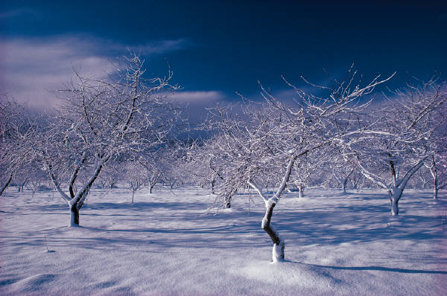

Sunday | Monday | Tuesday | Wednesday | Thursday | Friday | Saturday
 |  |  |  |  |  | 1
2 | 3 | 4 | 5 | 6 | 7 | 8
 | Begin Momentum:  -Collision types | *Impulse &  Collisions  *Momentum  cartoons | Momentum Pre-lab:  -Small scale  collisions |  | Momentum Lab:  -Conservation of p & KE
9 | 10 | 11 | 12 | 13 | 14 | 15
 | Momentum Lab:  -Conservation of p & KE | Momentum Lab:  -Data  analysis | Review Momentum:  -Practice  problems | Parent-Teacher Conferences (4,5,6 | Inservice Day
16 | 17 | 18 | 19 | 20 | 21 | 22
 | President’s Day | Momentum Lab:  -Part III (creating a crumple zone) |  | -Momentum Practice questions  -Finish lab reports | Impulse & Momentum review:  -Practice quiz
23 | 24 | 25 | 26 | 27 | 28 | 29
 | Impulse & Momentum unit exam | Begin Simple Harmonic Motion:  -Examples  -Period VS Frequency |  | SHM Lab:  - Factors that affect period  -Using photogate/motion detector to get period | SHM Lab:  - Collect Data

March
2020 Physics

Sunday | Monday | Tuesday | Wednesday | Thursday | Friday | Saturday
1 | 2 | 3 | 4 | 5 | 6 | 7
 | SHM Lab:  -Analyze Data  -Finish lab reports | SHM Problem Solving |  | SHM Review & Quiz | Teacher Work Day
8 | 9 | 10 | 11 | 12 | 13 | 14
 | Spring Break | Spring Break | Spring Break | Spring Break | Spring Break
15 | 16 | 17 | 18 | 19 | 20 | 21
 | Begin Waves  - Wave speed Inquiry lab | -Continue Wave speed Inquiry lab  -Properties of Waves |  | Applying the wave equation  -Ch 13 problems | *More Wave Properties:  -Doppler effect  -Interference  *Work on Ch 13 problems
22 | 23 | 24 | 25 | 26 | 27 | 28
 | Sound Waves Lab:  -Observing Waves  -Resonance | *Finish Sound Waves Lab:  - Beats & Interference  *Finish Ch 13 Problems |  | *Finish Sound mini lab  *Finish Wave Basics | Sound Waves Practice exercises:  -Doppler effect  -Sound intensity
29 | 30 | 31
 | *Ch 13 Review  (Kahoot?)  *Review of SHM & Sound waves | *SHM & Sound Waves test  *Intro. to properties of light

April
2020 Physics

Sunday | Monday | Tuesday | Wednesday | Thursday | Friday | Saturday
 |  |  | 1 | 2 | 3 | 4
 |  |  |  | Laser Target Shooting Lab  -Begin Planning | Laser Target Shooting Lab  -Begin Testing
5 | 6 | 7 | 8 | 9 | 10 | 11
 | Finish Laser Target Shooting Lab  -Simple Ray diagrams | Refraction:  -Snell’s law  -Lens Ray Diagrams |  | Refraction Lab:  -Real image formation  - Applying Snell’s Law (speed of light) | Refraction Lab:  -Real image formation  - Applying Snell’s Law
12 | 13 | 14 | 15 | 16 | 17 | 18
 | Review Properties of light | -Light & Optics Quiz  -Begin "Contact" |  | "Contact" movie & questions | Begin Electric Forces:  - Coulomb’s law  - Static electricity
19 | 20 | 21 | 22 | 23 | 24 | 25
 | Begin Electrostatics:  -Static electricity Lab | Finish Electrostatics Lab |  | *Begin circuits:  -reading schematics  -Ohm’s law | *Circuit practice questions
26 | 27 | 28 | 29 | 30
 | Basics of circuit building  - Wiring  - Using current & voltage meters | Simple Circuits lab:  -Series & Parallel circuits |  | Simple Circuits lab:  -Series & Parallel circuits

May
2020 Physics | 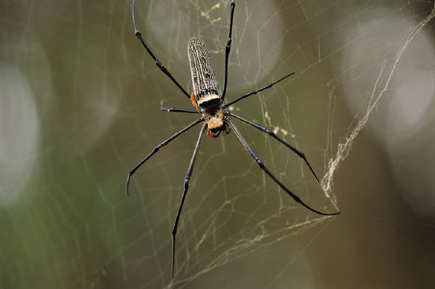

Sunday | Monday | Tuesday | Wednesday | Thursday | Friday | Saturday
 |  |  |  |  | 1 | 2
 |  |  |  |  | Finish DC Circuit problem
3 | 4 | 5 | 6 | 7 | 8 | 9
 | Using a Breadboard:  -Simple circuit construction | Breadboard * LEDs lab |  | -Finish Breadboard lab  -Review circuits | Circuits Quiz
10 | 11 | 12 | 13 | 14 | 15 | 16
 | Introduce Rube Goldberg project | Rube Goldberg construction |  | Rube Goldberg construction & Testing | -Final Rube Goldberg Test  -Begin Final Exam Reviews
17 | 18 | 19 | 20 | 21 | 22 | 23
 | Finals Review | Finals Review | Finals (1, 2, 3) | Finals (4, 5, 6) | Teacher Work Day
24/31 | 25 | 26 | 27 | 28 | 29 | 30

