January
2020 Biology | 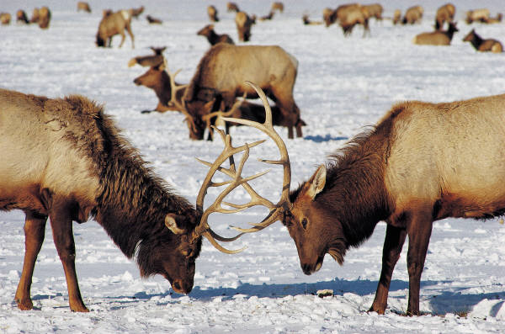

Sunday | Monday | Tuesday | Wednesday | Thursday | Friday | Saturday
 |  |  | 1 | 2 | 3 | 4
5 | 6 | 7 | 8 | 9 | 10 | 11
 | *Intro. To DNA:  - DNA origami  -DNA properties  -DNA Pogil |  | *DNA structure:  -Notes  *Finish DNA Pogil | *DNA extraction lab  *DNA modeling with candy  *DNA coloring | *Review DNA structure  -Finish DNA coloring
12 | 13 | 14 | 15 | 16 | 17 | 18
 | *DNA structure Quiz  *Intro. to the cell cycle:  -Cell Division |  | *Cell Division lab:  -Investigating stages of the cell cycle | *Cell Division lab:  -Graphing & Data Analysis
19 | 20 | 21 | 22 | 23 | 24 | 25
 | MLK Holiday |  | *The cell cycle & cancer:  -Mutations & their effects on cells/organisms  -Cancer Research intro. | Computer Lab:  -Cancer research  -Finish Cancer research paper | Computer Lab:  -Cancer research
26 | 27 | 28 | 29 | 30 | 31
 | -Cancer Research presentations |  | - Finish Cancer Research presentations  -Cell Cycel Flash Cards | -Cell Cycle Review  - Cell Cycle Quiz | *Intro to protein synthesis:  -Transcription  -Translation  *Protein synthesis race

February
2020 Biology

Sunday | Monday | Tuesday | Wednesday | Thursday | Friday | Saturday
 |  |  |  |  |  | 1
2 | 3 | 4 | 5 | 6 | 7 | 8
 | -Finish Protein Synth Race  -Practice Transcription & Translation |  | *Mutations:  -Types of mutations  - Effects of mutations  -Mutations by Analogy | -Finish Mutations by analogy  -Begin Review for Protein Synthesis Quiz | -Protein Synthesis Kahoot  -Begin Protein Synthesis Quiz
9 | 10 | 11 | 12 | 13 | 14 | 15
 | -Finish Protein Synthesis Quiz |  | Gattaca:  - Ethics in genetics  -Discussion questions | 1/2 Day  (p. 4, 5, 6) | Inservice
16 | 17 | 18 | 19 | 20 | 21 | 22
 | President's Day  Holiday |  | *Meiosis  -Notes  -Begin modeling lab | -Mendelian Genetics notes  -Practice Punnett Squares | -Genetics Basics Pogil (Dragon Genetics)
23 | 24 | 25 | 26 | 27 | 28 | 29
 | Genetics Escape Room:  -Applying genetics |  | - Finish Genetics Escape Room  -Superhero Genetics Lab | -Finish Superhero Genetics Lab  - Creating a Dragon with Genetics | -Finish Dragon Genetics Lab

March
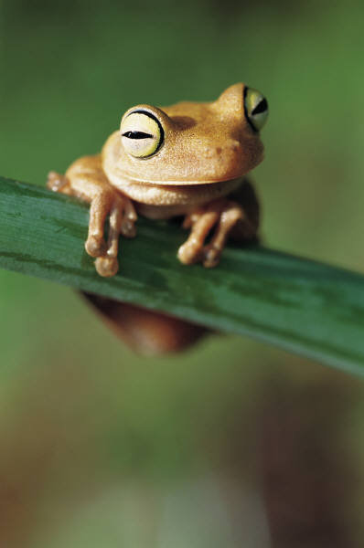
2020 Biology

Sunday | Monday | Tuesday | Wednesday | Thursday | Friday | Saturday
1 | 2 | 3 | 4 | 5 | 6 | 7
 | -Introduction to Pedigrees |  | -Practice Pedigrees  -Begin Genetics Review | -Genetics Study Guide  -Genetics Review Game  - | Inservice
8 | 9 | 10 | 11 | 12 | 13 | 14
 | Spring Break | Spring Break | Spring Break | Spring Break | Spring Break
15 | 16 | 17 | 18 | 19 | 20 | 21
 | -More Punnett Square Practice |  | -Practice Punnett Squares:  -Incomplete & codominance  -Multiple alleles  -Polygenic inheritance | *Genetics Terms card game:  -Taboo | *Finish Genetics Terms card game
22 | 23 | 24 | 25 | 26 | 27 | 28
 | Genetics Review Kahoot:  -Terms & Applying Mendelian Genetics |  | PEAKS Testing  (Work on Genetics study guide) | PEAKS Testing  (Work on Genetics study guide) | -Final Genetics Review  -Begin Genetics Unit Exam
29 | 30 | 31
 | Genetics Unit Exam

April
2020 Biology

Sunday | Monday | Tuesday | Wednesday | Thursday | Friday | Saturday
 |  |  | 1 | 2 | 3 | 4
 |  |  | Genetics Unit Exam | *Finish Genetics Unit Exam  *Rapid Evo article:  - Killifish | Introduction to Evolution:  -Brainstorming activity
5 | 6 | 7 | 8 | 9 | 10 | 11
 | Evolution Notes:  -Darwin's voyage  -Theory of Natural Selection |  | *Finish Evolution Notes  *Begin Create-a-Creature:  - Adaptations | *Evidence for Evolution:  - Summary vid.  - Finish Create-a-Creature | *Crash Course  Evolution Video  - Natural select.  *Turn in Create-a-Creature
12 | 13 | 14 | 15 | 16 | 17 | 18
 | Simulating Natural Selection:  -Darwin's Finches Lab |  | *Finish Darwin's Finches Lab  *Work on Evidence for Evolution Guide | * Begin Cladograms  -Phylogenetic relationships  -Creating cladograms | *Finish Cladograms  *Hardy-Weinberg:  -Notes  -Applying HW
19 | 20 | 21 | 22 | 23 | 24 | 25
 | HW Lab:  -Simulating Hardy-Weinberg |  | *Finish HW Lab  - Data analysis  *Review Evolution:  -Study Guide | *Evolution Review:  -Kahoot  -Finish Study Guide | *Evolution Unit TEST:  -Begin
26 | 27 | 28 | 29 | 30
 | Finish Evolution Unit Exam |  | Begin Survival of the Sweetest:  -Linking Evolution with Ecology | Finish Survival of the Sweetest

May
2020 Biology | 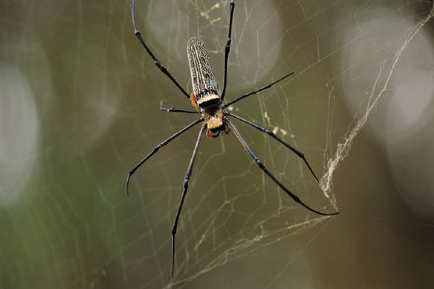

Sunday | Monday | Tuesday | Wednesday | Thursday | Friday | Saturday
 |  |  |  |  | 1 | 2
Begin Classification:
-Kingdoms of Life
-Dichotomous keys
3 | 4 | 5 | 6 | 7 | 8 | 9
 | Applying Dichotomous Keys:  -Identifying fish |  | Dichotomous keys lab:  -Specimen lab | Intro. To Animals:  -Basic Features  -Animal Phyla Project (Computer Lab) | Computer Lab:  Research Animal Phyla
10 | 11 | 12 | 13 | 14 | 15 | 16
 | Finish Animal Phyla Research |  | Animal Phyla Presentations:  -Survey of the Invertebrates | -Finish Animal Phyla Presentations  -Begin Final Exam Review | Final Exam Review
17 | 18 | 19 | 20 | 21 | 22 | 23
 | Final Exam Review | Final Exam Review | Final Exams:  Periods 1, 2, 3 | Final Exams:  Period 4, 5, 6 | Teacher Work Day
24/31 | 25 | 26 | 27 | 28 | 29 | 30

